Physics Higher Level 2023

**1.**

In an experiment to determine the acceleration due to gravity *g*, the time *t* for an object to fall from rest through a distance *s* was measured. The procedure was repeated for a series of values of *s.*

The following data were recorded.

1. **Draw a labelled diagram of the apparatus used in the experiment.**  
   object, release mechanism, pressure plate/trapdoor, means of measuring distance/time
2. **Indicate the distance *s* on your diagram.**From bottom of electromagnet to top of trapdoor or sensor.
3. **Describe how the time interval *t* was measured.**   
   Electronic timerstarted when object is released and stops when object hits plate
4. **Draw a suitable graph to show the relationship between *s* and *t*.**

|  |  |  |  |  |  |  |
| --- | --- | --- | --- | --- | --- | --- |
| *s* (cm) | 40 | 50 | 60 | 70 | 80 | 90 |
| *t* (cs) | 29 | 32 | 35 | 38 | 40 | 43 |
| *s* (m) | 0.4 | 0.5 | 0.6 | 0.7 | 0.8 | 0.9 |
| *t2* (s2) | 0.0841 | 0.1024 | 0.1225 | 0.1444 | 0.16 | 0.1849 |

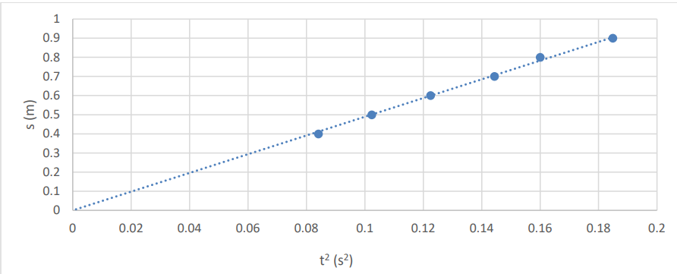

1. **Use the graph to calculate a value for *g*.**   
   slope formula   
   g ≈ 9.8 m s–2
2. **The object used was a smooth metal sphere. Explain why.**  
   It was smooth so as to reduce air resistance.  
   It was metal so that it has a high density / or because it needed to magnetic / or it needed to be a conductor (depending on apparatus setup).

**2.**

In an experiment to determine the focal length *f* of a concave mirror, a student first found an

approximate value for the focal length. She then measured the image distance *v* for a series of

|  |  |  |  |
| --- | --- | --- | --- |
| *u* (cm) | 20.0 | 30.0 | 40.0 |
| *v* (cm) | 66.3 | 31.1 | 25.2 |

object distances *u*.

The following data were recorded.

1. **How did the student find an approximate value for *f*?**  
   focus the image of a distant object on a screen.  
   measure the distance from the screen to the mirror
2. ***Why* did the student find an approximate value for *f?***object must be outside focal point / to get an image on the screen
3. **Draw a labelled diagram of the apparatus used in this experiment.**

**Show *u* and *v* on your diagram.**  
object, screen, mirror, *u* shown, *v* shown

1. **Describe how the student determined and measured *v*.**  
   move object/screen/mirror until a sharp image is formed on the screen.  
    measure v with a metre stick
2. **Use all of the data to calculate *f*.**  
   1/u + 1/v = 1/f   
   substitution for u and v   
   average of values for f = 15.4 cm

**3.**

In an experiment to determine the wavelength of monochromatic red light, a collimated beam of

light was incident perpendicular to a diffraction grating. The diffraction grating had 300 lines per mm.

A series of images was observed on a screen placed 75 cm from the grating.

The distance between the third order images on the screen was measured. They were 1.04 m apart.

1. **Draw a labelled diagram of how the apparatus was arranged in this experiment.**  
   source of light   
   screen/spectrometer  
   diffraction grating  
   arrangement
2. **How were the third order images identified?**   
   third image on both sides of central image
3. **Calculate the grating constant *d*.**  
   1/300000 ≈ 3.33 × 10–6 m
4. **Calculate the wavelength of the red light.**   
   nλ = d sinθ

n = 3

opposite = 1.04/2 = 0.52 m

$θ =\tan^{-1}{\frac{0.52}{0.75 }}$ = 34.74°

λ = 6.33 × 10–7 m

1. Describe how the pattern observed on the screen changes when:
   1. **the diffraction grating is replaced with a diffraction grating of fewer lines per mm,**  
      images are closer together
   2. **the red light is replaced with green light,**  
      images are closer together
   3. **the screen is moved further away from the grating.**  
      images are further apart

**4.**

In an experiment to determine the specific latent heat of vaporisation of water, cool water was

placed in a copper calorimeter.

Dry steam at a temperature of 100 °C was then added to the water.

|  |  |  |
| --- | --- | --- |
| Mass of calorimeter | | 65.8 g |
| Mass of calorimeter + water | before adding steam | 111.6 g |
| after adding steam | 114.3 g |
| Temperature of water | before adding steam | 5.5 °C |
| after adding steam | 36.4 °C |

The following data were recorded.

1. **Draw a labelled diagram of how the apparatus was arranged in this experiment.**  
   steam generator and delivery tube   
   calorimeter with water   
   thermometer   
   arrangement
2. **How did the student cool the water?**  
   refrigeration / ice bucket / adding ice which was allowed to melt completely / etc.
3. **How did the student dry the steam?**  
   steam trap / delivery tube sloped upwards / insulated delivery tube
4. **Why did the student cool the water?**   
   to make sure that the energy lost to surroundings cancelled the energy gained from surroundings /   
   to make sure that the steam condensed more quickly
5. **Why did the student dry the steam?**   
   to make sure that the steam had not lost its latent heat before it was added to the water / to make sure no water is added
6. **Use the data to calculate the specific latent heat of vaporisation of water.**   
     
   mwater = 45.8 g  
   msteam = 2.7 (g)  
   Δθwater = 30.9 °C  
   Δθsteam = 63.6 °C   
   *l* = 2.22 × 106 J kg–1

*specific heat capacity of water = 4180 J kg*–*1 K*–*1; specific heat capacity of copper = 390 J kg*–*1 K*–*1*

**5.**

A student investigated the variation of current *I* with potential difference *V* for a semiconductor

diode in forward bias.

|  |  |  |  |  |  |  |  |  |
| --- | --- | --- | --- | --- | --- | --- | --- | --- |
| *V* (v) | 0 | 0.1 | 0.2 | 0.3 | 0.4 | 0.5 | 0.6 | 0.7 |
| *I* (mA) | 0 | 0 | 0 | 0 | 5 | 20 | 70 | 220 |

The following data were recorded.

1. **Draw a circuit diagram for this experiment with the diode in forward bias.**  
   source of voltage   
   diode in forward bias  
   voltmeter across the diode  
   (milli)ammeter in series
2. **Draw a suitable graph to show the relationship between *I* and *V* for a diode in forward bias.**   
   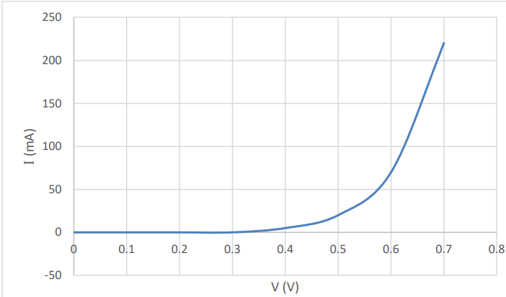
3. **Is Ohm’s law obeyed for this diode? Justify your answer.**   
   No, because it’s not a straight line going through the origin

The student then investigated the variation of current *I* with potential difference *V* for a diode in reverse bias. Several adjustments were made to the circuit.

1. **Draw a circuit diagram for this experiment with the diode in reverse bias.**  
   diode in reverse bias  
   voltmeter across the diode and (micro)ammeter
2. **Sketch a graph to show the relationship between *I* and *V* for a diode in reverse bias.**   
   axes labelled  
    correct shape

**6.** Answer any **eight** of the following parts, (*a)*, (*b*), (*c*), etc.

|  |  |
| --- | --- |
| An airplane starts from rest on a runway and reaches a velocity of 290 km hour–1 in 33 s.  Calculate the acceleration of the airplane in terms of *g*, the acceleration due to gravity. | 290 km hour–1 = 80.56 m s–1  *u* = 0, *v* = 80.56 m s–1  *v* = *u* + *at*, 80.56 = 0 + *a*(33)  *a* = 2.44 m s–2  Finally, to express this number in terms of *g* we need to divide by 9.8.  answer: *a* = 0.25 g |
| Explain the term *solar constant*. | This is the amount of solar energy falling normally on 1 m2 of the Earth every second. |
| A converging lens of focal length 15 cm is placed in combination with a diverging lens of focal length 5 cm.  Calculate the power of the combination. | P = 1/f  PTotal = P1 + P2  PTotal = 1/f1 + 1/f2 PTotal = 1/15 **-** 1/5 PTotal = –13.33 m–1 |
| Uranus has a mass of 8.7 × 1025 kg and a radius of 25 400 km.  Calculate the acceleration due to gravity on Uranus. | g = GM/d2  g = 8.99 m s–2 |
| Draw a diagram to show how a ray of light can be turned through 90° using a 45°–90°–45° prism. | ray entering normally at one short face  ray exiting at the other short face  reference to total internal reflection |
| State one application of stress polarisation. | e.g. to identify weaknesses in plastics |
| What is meant by potential difference? | work done per unit charge (moved between two points) |
| Calculate the power output of a resistor of resistance 3.4 Ω when a potential difference of 55 V is maintained across it. | P = VI; V = IR  P = 889.7 W |
| The peak voltage of an a.c. supply is 311 V. Calculate its rms voltage. | Vrms = Vpeak/√2   Vrms = 219.9 V |
| A proton experiences a force of 4.59 × 10–16 N when it moves with velocity *v* perpendicular to a magnetic field of flux density 18.5 mT. Calculate *v*. | *F* = *qvB*    *v* = 1.55 × 105 m s–1 |
| Explain what is meant by a chain reaction in nuclear fission. | neutrons from one reaction initiate subsequent reactions / cause a self-sustaining reaction |
| The equation to describe an emission line spectrum is *hf* = *E*2 *– E*1.  Explain what each of the symbols in this equation stands for. | *h* = Planck constant  *f* = frequency E2 = higher energy E*1* = lower energy |

**Question 7 Higher Level 2023**

1. **State Newton’s third law of motion.**  
   When object A applies a force on object B, object B applies an equal but opposite force on object A
2. Show that *F* = *ma* is a special case of Newton’s second law of motion. $F∝\frac{mv-mu}{t}$ $F∝m(\frac{v-u}{t})$ $F∝ma$
    F = *k* (ma)

But *k* = 1 (from our definition of the newton).

Therefore F = ma

1. A force of 6.8 kN is applied to a golf ball at rest by the head of a golf club.

The ball has a mass of 45.6 g and the club and ball are in contact for a time of 0.51 ms.

Calculate the velocity of the ball immediately after impact.  
  
*F* =6800 N*, m* = 0.456 kg, *u* = 0 m s–1, *v* = ?, *t* = 0.51 × 10-3 s

*v* = 76.05 m s–1

1. The velocity of the ball immediately after impact is at an angle of 15° to the horizontal.

**Draw separate diagrams to show the forces acting on the ball**

* 1. **during impact**  
     weight down

force applied by club

* 1. **immediately after impact.**  
     This is cool. The temptation is to show a force pushing the ball forwards (because that’s the way it’s moving) but once the club loses contact with the ball there is no longer any force pushing the ball forward. It is now simply following Newton’s first law of motion and is simply moving due to inertia.

**Therefore there is only one force acting on the ball:** weight acting downwards.

1. **Calculate the maximum height reached by the ball.**  
   *uy* = 76.05 sin 15°

*v*2 = *u*2 + 2*as*   
*s* = 19.77 m

1. **Calculate the time it takes for the ball to travel a horizontal distance of 280 m.**   
   *vx* = 76.05 cos 15°   
   *v* = *s*/*t*  
   *t* = 3.81 s
2. A wind blows as the ball travels through the air.   
   The wind has a velocity of 8.2 m s–1 east and 3.7 m s–1 north.

**Calculate the magnitude and direction of the velocity of the wind.**

a2 = b2 + c2   
*v* = 9.0 m s–1   
tan θ = opposite/adjacent   
θ = 24.3° North of East

**Question 8 Higher Level 2023**

The strings of a guitar can be plucked so that they vibrate at certain frequencies.

The guitar and the air inside it also vibrate due to resonance**.**

1. **What is resonance?**  
   the transfer of energy between two systems with the same natural frequency
2. **Describe a laboratory experiment to demonstrate resonance.**

* 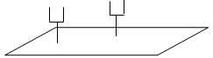Use two ***identical*** tuning forks (same frequency) and a sound-board.
* Start one fork vibrating and place it on the sound-board.
* Place the second tuning fork on the sound-board and then stop the first tuning fork from vibrating.
* The second fork can now be heard vibrating.

1. The frequency *f* of a stretched string depends on its length *l*, tension *T* and linear density (mass per unit length) *μ*.

For each of the following pairs of variables, sketch a suitable graph to show the relationship between them.

* 1. ***f* and *T*** *f is proportional to √T, therefore we need a graph of f against √T   
     labelled axis and straight line through the origin*
  2. ***f* and *l***

*f is proportional to 1/length, therefore we need a graph of f against 1/length  
labelled axis and straight line through the origin*

* 1. ***f* and *μ*** *f is proportional to 1/√μ, therefore we need a graph of f against 1/√μ  
     labelled axis and straight line through the origin*

*Note that if we want to show that two variables are proportional then we just need to plot a graph of one against the other and show that we get a straight line through the origin. This will happen regardless of which quantity is on which axis.*

1. **For each of the following variables, state the effect on the frequency *f* if the variable is increased by a factor of four.**
   1. ***Tension*** *f is proportional to √T*

*So if frequency increases by a factor of 4 then tension would increase by a factor of √4 or 2.*

*i.e. tension in will increase by a factor of 2*

* 1. ***length*** *f is proportional to 1/length, so if frequency increases by a factor of 4 then length would* ***decrease*** *by a factor of 4.*
  2. ***μ*** *f is proportional to 1/√μ, so if frequency increases by a factor of 4 then μ would decrease by √4, i.e. μ (mass per unit length) in will* ***decrease*** *by a factor of 2.*

A string is stretched between two fixed points which are 62 cm apart. The string vibrates with a number of different harmonics. The speed of sound in the string is 380 m s–1.

1. **What are harmonics?**  
   Harmonics are frequencies which are multiples of the fundamental frequency.
2. A pair of glasses

   Description automatically generated with low confidence**Draw a diagram to show the string vibrating at its third harmonic.**  
   We need a node at both ends and three anti-nodes.

1. **Calculate the frequency of the string when it is vibrating at its third harmonic.**   
   In this case there are 1½ wavelengths in the waveform

$\frac{3λ}{2}=0.62 m$ λ = 0.4133 m

c = 380 m s−1 *c = fλ f* = 919.4 Hz

**Question 9 Higher Level 2023**

Voyager I and Voyager II are spacecraft that were launched in 1977 to investigate the outer planets of our solar system.

The spacecraft are powered with radioisotope thermoelectric generators.

When the spacecraft were launched, each generator contained 4 kg of plutonium–238.

Each atom of plutonium–238 has a mass of 3.9529085 × 10–25 kg.

1. **Write a nuclear equation for the alpha decay of plutonium–238.**

$${}_{94}^{240}{Pu} →{}_{2}^{4}{He+ {}_{92}^{236}U}$$

1. **Calculate the energy released during each decay of plutonium–238, in MeV.**  
   First convert the mass of each particle from u to kg

Then subtract the total mass on the right hand side from the total mass on the left hand side.  
Mass defect = 9.95757 × 10–30 kg  
E = mc2

E = (89.95757 × 10–30)(3 × 108)2.

E = 8.95 × 10–13 J

To convert from joules into eV we need to divide 8.95 × 10–13 by the energy of one eV (1.6 × 10-19).

E = 5.6 × 106 eV = 5.6 MeV

1. The energy released by the decay is converted into electrical energy in thermocouples.

**State the thermometric property of a thermocouple.**  
emf / voltage

1. Diagram

   Description automatically generated**Draw a labelled diagram of the arrangement of a thermocouple.**   
   two different metals  
   first junction at one temperature  
   second junction at a different temperature
2. Plutonium–238 has a half‐life of 87.8 years.

Calculate the rate of decay of the plutonium in each generator in 1977.  
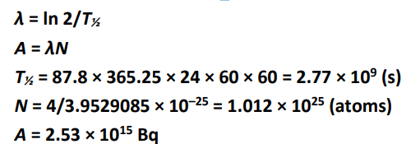

|  |  |
| --- | --- |
|  | = 2.77 × 109 s  A = λN  Next we need to calculate *N* - the number of nuclei  We have 4 kg of plutonium–238 and each atom of plutonium–238 has a mass of 3.9529085 × 10–25 kg.  So total number of atoms (N) = 4 ÷ 3.9529085 × 10–25 = 1.012 × 1025 atoms.  A = λN (5.09 × 10-11) × (1.012 × 1025) = 2.53 × 1015 Bq |

1. **Calculate the year when only 1 kg of the plutonium will remain in each generator.**

After one half-life, half of the original sample of 4 kg (ie 2 kg) will remain.

After two half-lifes, one quarter of the original sample of 4 kg (ie 1 kg) will remain.

1977 + 2 half-lives = 1977 + (2 × 87.8) = 2152

1. The Voyager spacecraft are now beyond our solar system and they are maintaining constant velocities.   
   **Use one of Newton’s laws to explain why the spacecraft maintain constant velocities.**

There are no forces acting on them so from Newton’s first law there will be no change in their velocities.

**Question 10 Higher Level 2023**

The Van de Graaff generator is named after the American physicist Robert J. Van de Graaff.

It is an electrostatic generator that accumulates charge on a hollow metal dome and produces high voltages which can be used in the production of X‐rays.

In a Van de Graaff generator, point discharge is used to move charge on to a belt at the lower comb in the generator.

1. **Describe how point discharge occurs.**  
   accumulation of charge at a point   
   large electric field generated / ionisation of the air  
   unlike charges attract and like charges repel
2. **Describe a laboratory experiment to demonstrate point discharge.**   
   apparatus  
   method  
   observation
3. The dome of a Van de Graaff generator has a diameter of 32 cm.

A large electric field exists around the dome when it is given a charge of +200 nC.

**Draw the electric field around the dome.**radial field lines away from the dome

1. **Calculate the electric field strength at the surface of the dome.**  
   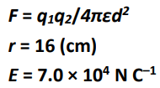
2. **Calculate the force experienced by an electron placed at the surface of the dome.**  
   E = F/q  
   F = 1.12 × 10–14 N towards the centre of the dome
3. A voltage of 70 kV is applied across an X‐ray tube.

**Calculate the maximum speed of the electrons produced in the tube.**

qV = ½mv2   
*velocity* = 1.57 × 108 m s–1

1. **Draw a labelled diagram of an X‐ray tube.**

low voltage filament / heating coil   
cathode & anode/target  
high voltage between cathode & anode

cooling

shielding

window

partial vacuum

**Question 11 Higher Level 2023**

Metal detectors are used in treasure hunting and in airport security.

They operate on the principle of electromagnetic induction. The coil in the detector is supplied with an alternating current.

1. **Give a detailed explanation of how a current is induced in the metal that is being detected.**   
   The alternating current in the coil has a changing magnetic field   
   When this changing magnetic fields cuts or passes through the metal an emf induced in the metal.

This in turn induces a current to flow in the metal that is being detected.

The magnitude and direction of an induced emf are determined by Faraday’s law of electromagnetic induction and Lenz’s law of electromagnetic induction.

1. **State Faraday’s law of electromagnetic induction.**  
   Size of induced emf induced is proportional to the rate of change of magnetic flux
2. **State Lenz’s law of electromagnetic induction**.  
   The direction of an induced current/emf is such as to oppose the change causing it
3. **Describe a laboratory experiment to demonstrate either one of these laws.**

See notes

A circular coil of 500 turns and radius 6.0 cm enters a magnetic field moving with a constant velocity of 8 m s–1 perpendicular to the field.

The resistance of the coil is 2.3 Ω and the magnetic flux density of the field is 4.5 mT.

1. **Calculate the time taken for the coil to fully enter the field.**

A diagram would have been nice here which is why I have included it in the solution (note that total distance travelled = diameter of the coil = 12 cm = 0.12 m).

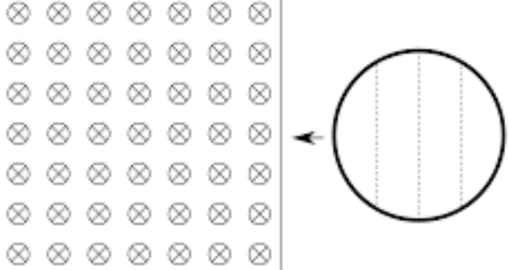

$$velocity=\frac{displacement}{time}$$

$$time=\frac{displacement}{velocity}= \frac{0.12}{8}$$

t = 0.015 s

1. **Calculate the average emf induced as the coil enters the field.**

*A = πr2* = π(0.06)2 = 0.011 m2.

B = 4.5 × 10-3 T

Φ *= BA*  *=* (4.5 × 10-3)( 0.011) = 5.089 × 10-5 Wb

Induced emf = $\left(N\right)[\frac{change in flux}{time taken}]$ = $\left(500\right)\left[\frac{ {5.089×10}^{-5}-0}{0.015}\right]$ = 1.7 V

1. **Calculate the average current in the coil as it enters the field.**   
   V = IR

R = 2.3 Ω, V = 1.7 V I = V/R = 1.7/2.3 = 0.74 A

**Question 12 Higher Level 2023**

Answer **either** part (*a*) or part (*b*).

(*a*) Anti‐matter is the most expensive substance on Earth, costing about €65 trillion per gram.

1. **What is anti‐matter?**  
   same mass but opposite charge as its matter equivalent
2. **Who made a mathematical prediction of the existence of anti‐matter?**  
   Paul Dirac
3. A positron is an example of anti‐matter.

**Write an equation to show the pair production of an electron‐positron pair.**  
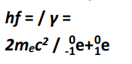

1. **Explain how (*a*) charge, (*b*) momentum are conserved in this interaction.**  
   a charge before = charge after = 0   
   b momentum before = momentum after ≈ 0 / particles move in opposing directions
2. **List the fundamental forces, in order of increasing strength, that a positron experiences.**  
   gravitational, weak, electromagnetic
3. **Name the fundamental force that a positron does *not* experience.**   
   Strong nuclear force
4. In the Large Hadron Collider researchers are investigating the pair annihilation of a proton anti‐proton pair.

**Calculate the wavelength of the electromagnetic radiation produced when a proton and an anti‐proton annihilate.**  
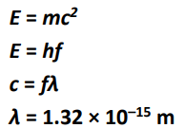

1. **Hadrons can be classified as baryons or mesons. Distinguish between baryons and mesons.**  
   a baryon contains three quarks  
    a meson contains a quark and an anti-quark
2. **State the quark composition of (*a*) a proton, (*b*) an anti‐proton.**  
   a: up, up, down  
   b: anti-up, anti-up, anti-down
3. The Large Hadron Collider is an example of a modern particle accelerator.   
   **Explain how it differs from the particle accelerator used by Cockroft and Walton.**  
   It is circular as opposed to linear

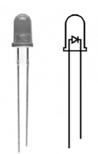

(*b*)

1. Draw labelled diagrams to show the basic structure of (*a*) the semiconductor diode, (*b*) the transistor.
2. Light emitting diodes and bridge rectifiers are examples of diodes in use.

Describe the principle of operation of a light emitting diode.

1. State one use of a light emitting diode.
2. Draw a circuit diagram, including a bridge rectifier and a capacitor, that can be used to convert a.c. to d.c..
3. Draw a circuit diagram to show how a transistor can be used as a voltage inverter.
4. A voltage inverter is a NOT gate. Draw its truth table.
5. Electromagnetic relays are sometimes used with transistors.

Draw a labelled diagram of an electromagnetic relay.

1. What is the function of an electromagnetic relay?

**Question 13 Higher Level 2023**

Read the following passage and answer the accompanying questions.

The electric power grid operates based on a delicate balance between supply and demand.

One way to help balance fluctuations in electricity supply and demand is to store electricity during

periods of high production and low demand, then release it back to the electric power grid during

periods of low production and high demand.

Energy can be stored in a variety of ways, including:

* 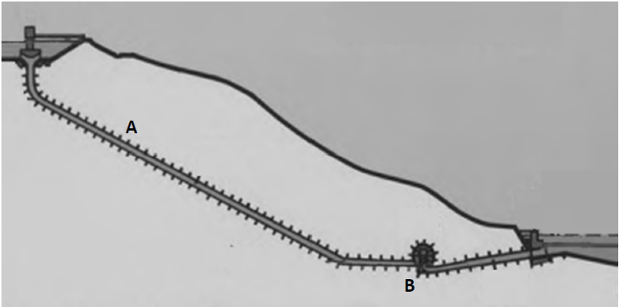Pumped storage: e.g. Turlough Hill, a pumped storage power station in Wicklow. It makes use of two water reservoirs, an artificial upper reservoir near the top of a mountain and the naturally occurring corrie lake, Lough Nahanagan, a lower reservoir which is 321 m below.

The upper reservoir has a volume of 2.3 × 106 m3.

The two reservoirs are connected by a pipe of length 584 m. A motor pumps water from the lower reservoir to the upper reservoir, using surplus power available at times of low demand. Water is then allowed to fall by gravity from the upper reservoir back into the lower reservoir, passing through turbines attached to electric generators along the way.

* Flywheels: electricity is used to accelerate a large heavy flywheel which stores rotational kinetic energy.
* Batteries: similar to common rechargeable batteries, very large batteries can store electricity.

Adapted from: *epa.gov/energy/electricity‐storage* and *wikipedia.org/wiki/Turlough_Hill_Power_Station*

1. Assume that the upper reservoir in Turlough Hill is full.
2. Calculate
   1. **the mass (in kg) of water in this reservoir**  
      ρ = m/V  
      m = 2.29 × 109 kg
   2. **the potential energy (in J) stored in this reservoir**  
      E = mgh

E = 7.21 × 1012 J

* 1. **the maximum power (in W) that could be generated if the reservoir was fully emptied in 24 hours.**   
     P = E/t  
     P = 8.35 × 107 W

1. **State the main energy conversion that takes place   
   (*a*) as the water flows down through the pipe at position A and   
   (*b*) as the water flows through the generator at position B.**   
   a: gravitational/potential to kinetic

b: kinetic to electrical

1. A motor operates on the principle that a current carrying conductor in a magnetic field experiences a force. **Describe a laboratory experiment to demonstrate this principle.**   
   apparatus   
   method   
   observation
2. A flywheel of diameter 1.4 m rotates with 5000 revolutions per minute.

Calculate

* 1. **the period (in s) of the flywheel’s motion**  
     T = 1/f  
     T = 0.012 s
  2. **the angular velocity of the flywheel,**  
     T = 2π/ω   
     ω = 523.6 radians s–1
  3. **the centripetal acceleration at the circumference of the flywheel.**   
     a = rω2  
     a = 1.9 × 105 m s–2 towards the centre

1. **A battery is a source of emf. Name two other sources of emf.**   
   e.g. mains, solar cell, thermocouple, etc
2. As we move away from generating electricity using non‐renewable sources (e.g. fossil fuels) towards generating electricity using renewable sources (e.g. wind, solar) **it is more essential than ever to have energy storage systems such as the ones described in the text. Explain why.**   
   renewable sources are more likely to vary in the rate at which they produce electricity

*acceleration due to gravity = 9.8 m s–2; density of water = 0.997 g cm–3*

**Question 14 (a) Higher Level 2023**

In 1660 Robert Hooke investigated the elasticity of materials, including springs.

His work led to Hooke’s law.

1. **State Hooke’s law.**  
   For a stretched string the restoring force is proportional to displacement

A spring has a natural length of 15.0 cm. When a block of mass 500 g is hung from the spring, its length increases to 17.5 cm. The block is then pulled down further, released and begins to oscillate.

1. **Calculate the elastic constant of the spring.**  
   mg = ks  
   k = 196 N m–1
2. **Calculate the period of oscillation of the block.**   
   T = 2π/ω  
   ω = √(k/m)  
   T = 0.32 s
3. In 1665 Hooke, working as an assistant to Robert Boyle, built the vacuum pump that was used in the experiment that led to Boyle’s law.

**Sketch a graph that explains Boyle’s law. Label the axes on your graph.**Axes labelled as p and 1/V   
straight line through the origin

**Question 14 (b) Higher Level 2023**

A speaker emits a sound of fixed frequency. The speaker is moving at a constant velocity

towards an observer. The observer hears a frequency which is 20% greater than the frequency emitted.

1. **Name the effect which causes this increase in frequency.**  
   Doppler
2. **Calculate the speed of the speaker.**  
   f' = cf/(c ± u)

substitution   
u = 56.7 m s–1

1. **Red shift in astronomy is also due to this effect. What does red shift tell us about our universe?**   
   it is expanding

A fixed speaker of power *P* is emitting sound. At a certain distance from the speaker, an observer can measure both the sound intensity and the sound intensity level due to the speaker.

1. **Distinguish between sound intensity and sound intensity level.**  
   sound intensity is measured in W m-2   
   sound intensity level is measured in dB
2. The speaker of power *P* is replaced by a speaker of power 4*P.*

**Calculate the increase in sound intensity level measured.**   
Reference to 3 dB /   
doubling / 𝑰ntensity ∝ 𝑷ower   
6 dB

*speed of sound in air = 340 m s–1*

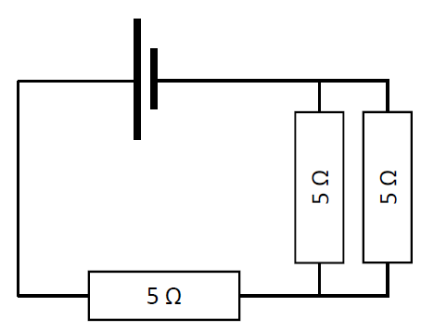**Question 14 (c) Higher Level 2023**

A metal wire has length *l*, resistance *R* and cross‐sectional area *A*.

1. **State the relationship between *R* and *A* for the wire.**  
   inversely proportional
2. **Using an appropriate diagram, derive an expression for the effective resistance of two resistors *R1* and *R2* in series.**   
   VT = V1 + V2

IRT = IR1 + IR2

RT = R1 + R2

1. **Calculate the total resistance of the circuit shown.**  
   1/Rp = 1/R1 + 1/R2  
   Rp = 2.5 Ω  
   RT = 7.5 Ω
2. **Describe how a fourth 5 Ω resistor could be added to the circuit so as to reduce the total effective resistance of the circuit.**   
   It would have to be arranged in parallel with the either the single resistor or the pair of resistors.

**Question 14 (d) Higher Level 2023**

1. **Distinguish between thermionic emission and the photoelectric effect.**  
   thermionic emission is caused by heat  
   the photoelectric effect is caused by light
2. **Describe a laboratory experiment to demonstrate the photoelectric effect.**   
   apparatus  
   method   
   observation
3. Electrons of maximum velocity 0.023c are emitted when electromagnetic radiation is incident on a zinc metal plate. Zinc has a work function of 4.3 eV.

**Calculate the frequency of the incident radiation.**  
h*f* = Ø + Ek  
Ek = ½mv2  
Ø = 4.3 × (1.6 × 10–19) = 6.88 × 10–19 J  
*v* = 6.9 × 106 m s–1  
*f* = 3.37 × 1016Hz